

**Politecnico di Milano**  
Dipartimento di Scienze e Tecnologie Aerospaziali  
Prova finale: Introduzione all’Analisi di Missioni Spaziali  
Docente: Massari Mauro

Elaborato n. C13

Autori:

|  |  |
| --- | --- |
| 10694997 | Pala Silvia |
| 10711624 | Turcu Alex Cristian |
| 10730510 | Vanelli Paolo |

Anno Accademico 2022-2023

Data di consegna: 00/00/00

# Table of contents

Table of contents 2

1. Introduction 3

2. Initial orbit characterization 4

2.1 Initial orbital parameters 4

2.2 Data interpretation 4

2.3 Graphical representation 4

3. Initial orbit characterization 5

3.1 Initial orbital parameters 5

3.2 Data interpretation 5

3.3 Graphical representation 5

4. Transfer trajectory definition and analysis 6

4.1.1 Standard Strategy 6

4.1.2 Possible alternative and decision explanations 6

4.1.3 Graphics 6

4.2 Alternative Strategy 1 7

4.3 Alternative Strategy 2 7

4.4 Alternative Strategy 3 7

5. Conclusions 7

6. Appendix 7

# Introduction

The project aims to study, optimize and choose various orbital transfer strategies, having as initial data a point on the initial orbit, which position and velocity vectors are given, and a point on the final orbit, which is defined by its orbital parameters.

First it will be analysed a strategy based on a set of standard manoeuvres.

Several other alternative strategies have been examined to try to optimize the two most significant parameters in their distinction: the manoeuvring cost (the total speed gap required to complete all the orbital changes) and the operating time (from the start point to the final point).

All calculations and plots are made using MATLAB software.

# Initial orbit characterization

## Initial orbital parameters

The assigned starting position and velocity vectors are the following:

It is possible to calculate the orbital parameters assigned to this specific couple of vectors:

|  |  |  |  |  |  |
| --- | --- | --- | --- | --- | --- |
|  |  |  |  |  |  |
| 8369.7448 | 0.1097 | 0.8487 | 1.5339 | 1.1849 | 1.8025 |

## Data interpretation

The starting geocentric orbit is elliptical, with an eccentricity value between 0 and 1 and a specific energy of:

It belongs to Medium Earth Orbit (MEO) category, as its apogee and its perigee are inside the range of 8000 – 42000 km:

According to the given value, it is nor a polar nor a geo-synchronous orbit and has a period of:

## Graphical representation

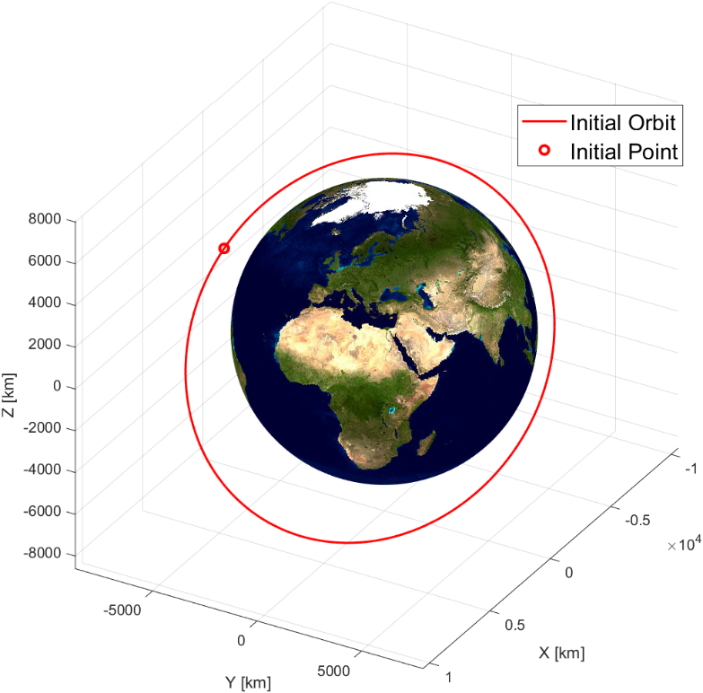

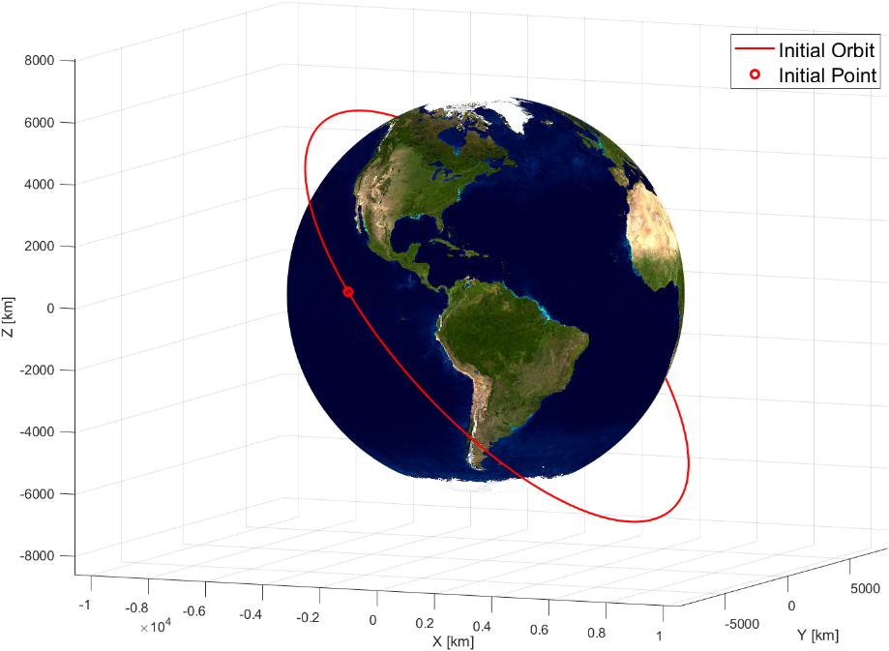

# Final orbit characterization

## Final orbital parameters

The goal orbit, that is geocentric just like the starting one, is defined by its orbital parameters:

|  |  |  |  |  |  |
| --- | --- | --- | --- | --- | --- |
|  |  |  |  |  |  |
| 10860 | 0.2332 | 0.5284 | 3.0230 | 0.4299 | 0.3316 |

The final position and velocity are calculated from these parameters:

## 3.2 Data interpretation

The final geocentric orbit is elliptical, with an eccentricity value between 0 and 1 and a specific energy of:

It belongs to Medium Earth Orbit (MEO) category, as its apogee and its perigee are inside the range of 8000 – 42000 km:

According to the given value, it is nor a polar nor a geo-synchronous orbit and has a period of:

## 3.3 Graphical representation

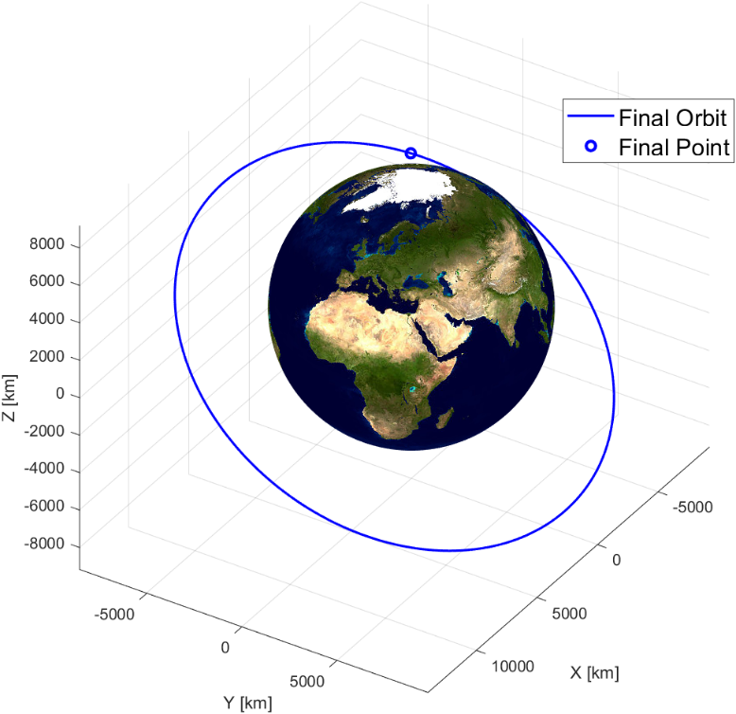

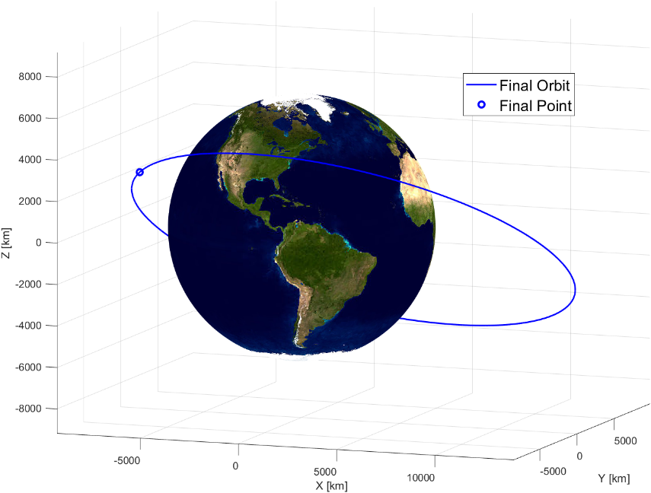

# Transfer trajectory definition and analysis

## 4.1.1 Standard Strategy

It is possible to reach the final assigned point, located on the final orbit, from the initial point on the initial orbit, through a standard strategy using a specific permutation of the three known manoeuvres between orbits. The chosen standard strategy is composed of, in sequence, a bitangent transfer perigee to apogee, a change of the orbital plane and a change of the pericentre’s anomaly. Each manoeuvre changes a specific set of orbital parameters.

1. Bitangent manoeuvre: to perform the first manoeuvre, it is needed to reach the first orbit’s pericentre, due to the nature of the bitangent chosen manoeuvre, where the first impulse is made, moving the satellite on a new orbit, that differs from the previous orbit with a new major semiaxis and a new eccentricity.
2. Transfer orbit: once reached the apogee of the second orbit, through another impulse, the satellite is transferred to a third orbit with the same major semiaxis and same eccentricity as the final assigned orbit.
3. Change in orbital plane: given the finale inclination, it is needed to change the inclination of the orbit in a specific point. Through this manoeuvre the final inclination and final RAAN can be achieved.
4. Change in argument of periapsis: a final impulse is needed to reach the configuration of the final orbit, as the argument of the periapsis of the final orbit is different. The final point is then reached after a short travel on the final orbit.

## 4.1.2 Standard’s alternatives and decision explanations

Among the possible permutation it has been chosen to perform the strategy as described in paragraph 4.1.1. Data of this strategy are shown in table 1. This strategy has been selected due to the lowest possible costs in term of change in velocity required, up to 27.3% compared with data reported below. It is possible to achieve this result thanks to some accouterments, such as the change of inclination, the most resource consuming transfer, done in the farthest point possible, thus not as the first manoeuvre, as in table 2 and 3, with savings up to 13.6% in . Moreover, the costs associated with the bitangent manoeuvre chosen, if done prior to the change in orbital plane, are significantly lower than any other bitangent transfer possible, with a reduction of up to BANANA There are no benefits in term of in doing a bitangent manoeuvre after the change in orbital plane.

In regards of the time required by the strategy proposed in table 1, these are higher than 21.1% compared to the strategy in table. The time required is greater because the orbits travelled are wider to reduce . Costs associated with the change in pericentre are not the lowest BANANA in table 1 but are necessaire as the at the end of the process is lower.

## 4.1.3 Proposed strategy’s graphic

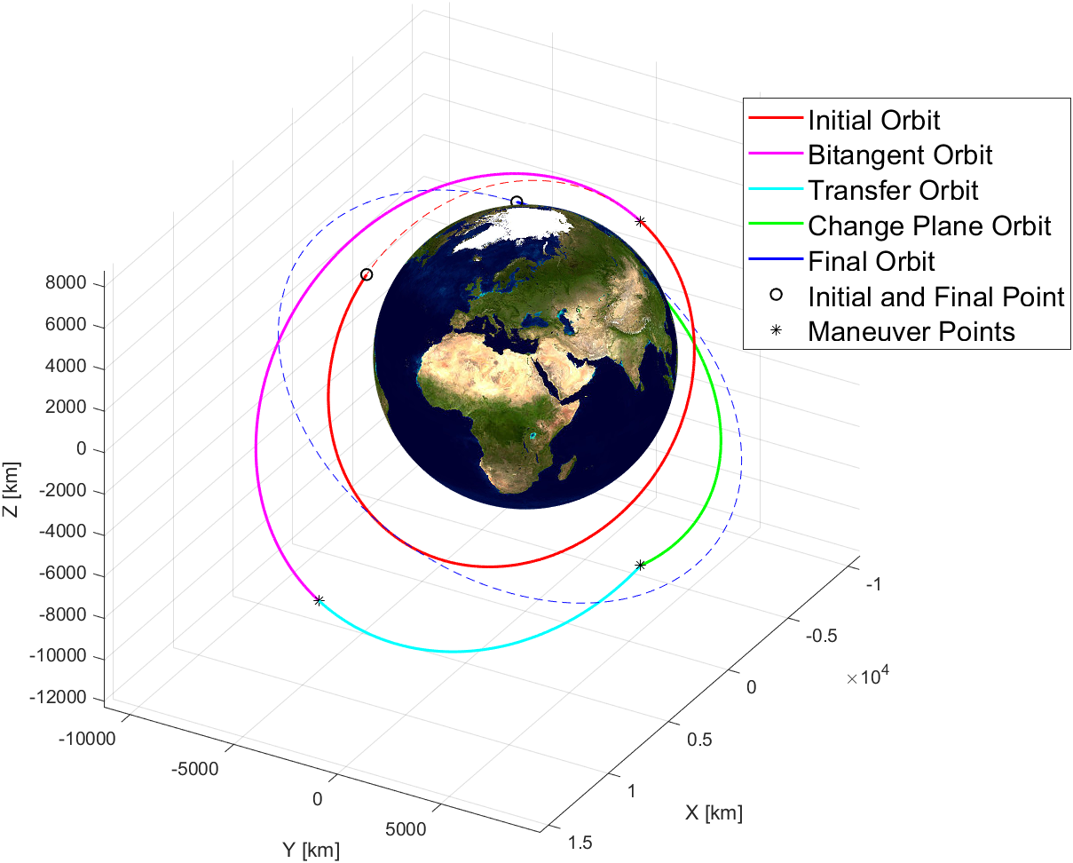

## 4.2 Alternative Strategy 1

## 4.3 Alternative Strategy 2

## 4.4 Alternative Strategy 3

# 5. Conclusions

# 6. Appendix